TERRAFORM CHALLENGES-02
Goal of the Exercise
The goal of this exercise is to test your understanding of a Cloud Compute deployment with Terraform.
You are tasked with creating a codebase for a microservice deployment on a cloud environment, using Terraform. Since our focus is not the application itself, the service will be a simple web server that returns a static page.
Requirements
Service Details
• The service will be a simple web server that returns a static page.
• You can use apache2 or nginx to serve a simple HTML file.
• The service should be containerized and stored in a Docker registry.
• The service should be deployed on a single VM instance as a Docker container.
• The image should be pulled from the registry specified earlier.
• The service should not be accessible from the internet but only through a Load Balancer, except for SSH access from specific IP addresses.

Deliverables
You are to provide the following as part of your solution:
• Dockerfile to build the image.
• Terraform codebase to deploy the following:
- Docker registry
- VPC and all required networking resources
- EC2 instance
- Load Balancer
Notes
• Since a CI/CD pipeline is not part of this exercise, we will work around that with the help of Terraform.
• To push the image to the Docker registry, build the image locally before running the Terraform code.
• Once the image registry is created, use Terraform to push the local image to the registry.
• Similarly, use Terraform to pull the image from the registry and run it on the VM instance once it is created.
• For SSH access:
- Use a locally created key.
- Add it to the cloud provider key storage.
- Attach it to the instance.
• Use Terraform best practices for file structure and code organization.
- Use variables, locals, modules, etc. when appropriate.
• Include all tfvars, scripts, and other helper files used to deploy the application.
• You may use any cloud provider of your choosing, although AWS is preferred.
• Use a free tier account or a trial account to deploy the resources.
Created ALL root files
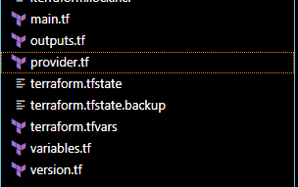
Created provider.tf
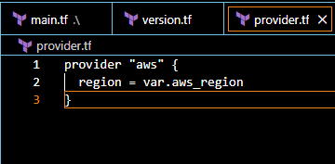
Created versions.tf
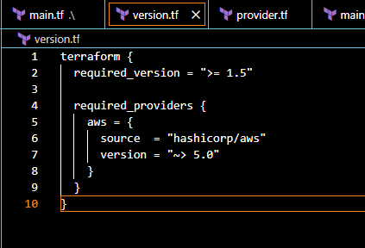
Created main.tf
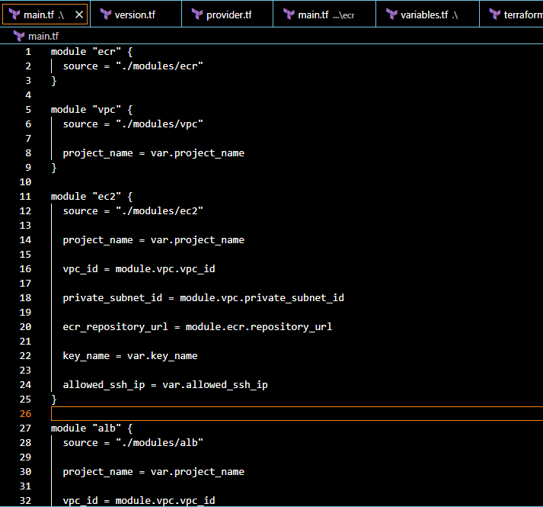
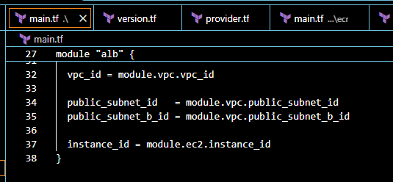
Created variables.tf
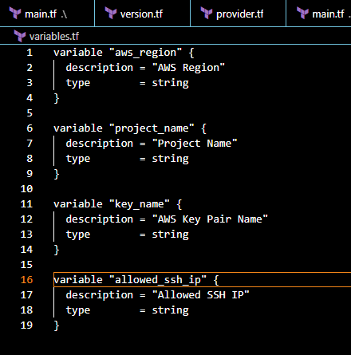
Created outputs.tf
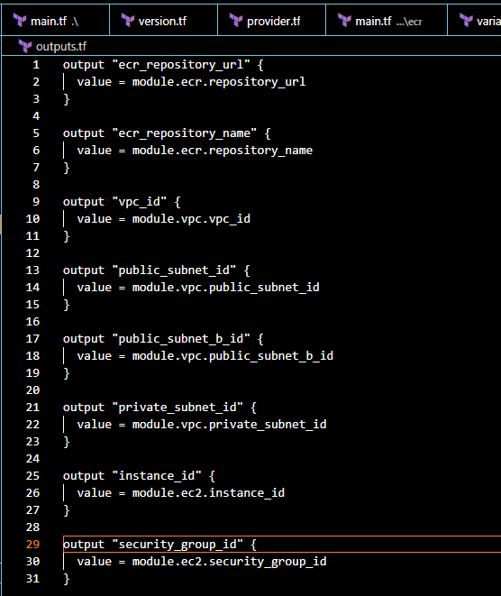
Created terraform. tfvars
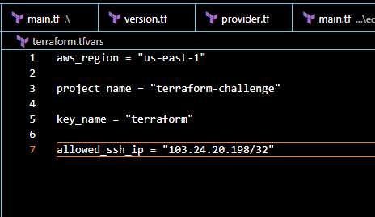
Created modules
ECR (Elastic container registry)
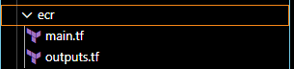
main.tf
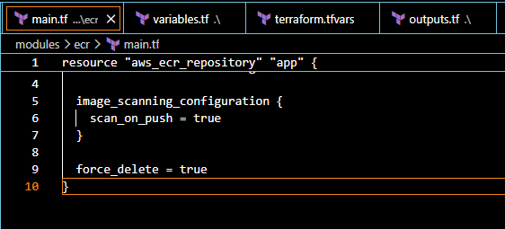
outputs.tf
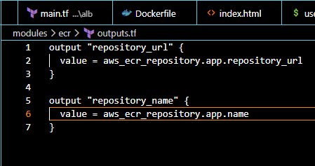
Executed all these comands terrform init, terrform fmt, terraform validate, terraform plan, terrafprm apply
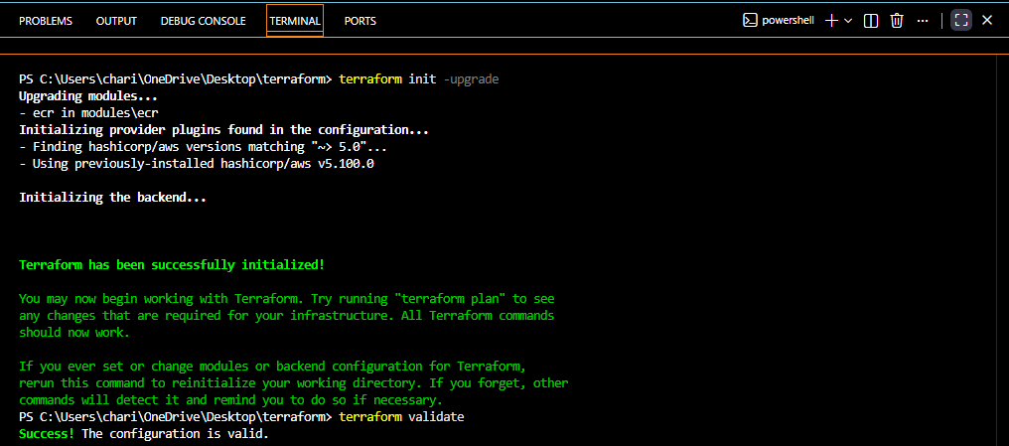
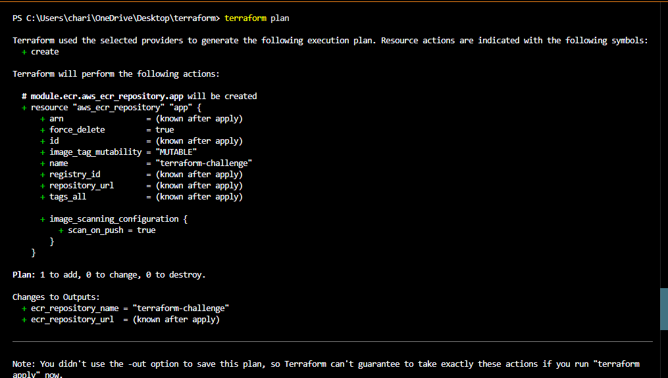
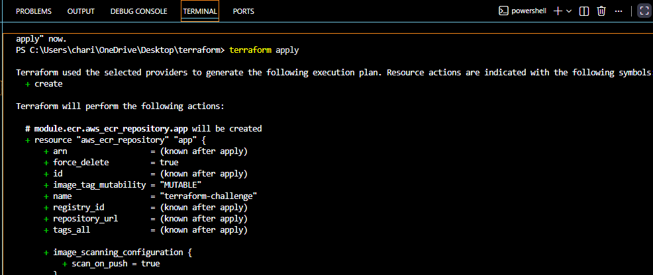
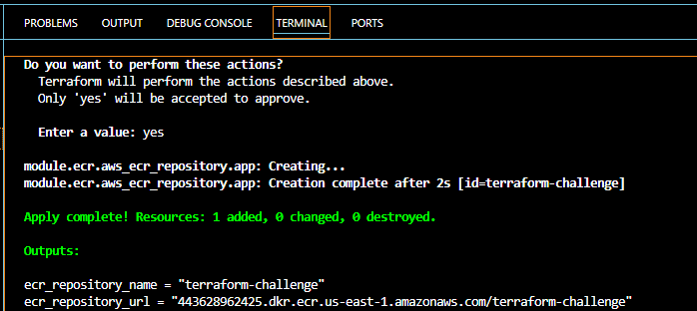
Verified in AWS account ECR is created
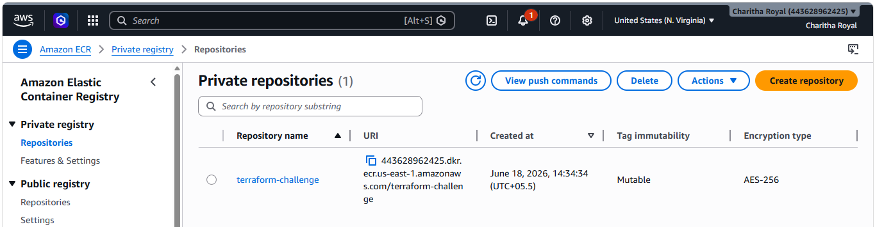

vpc (virtual private cloud)
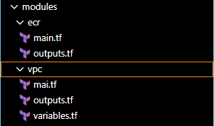
main.tf file for vpc
To create Vpc
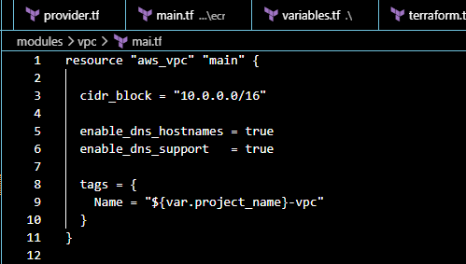
To create private and public subnets
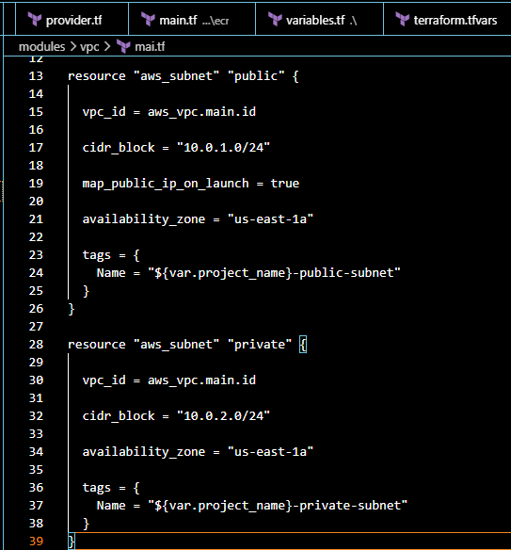
To create Routing tables and Internet gateway (IGW) and Nat gateway (NAT)

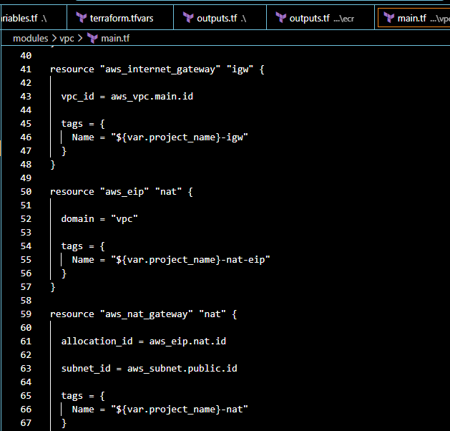
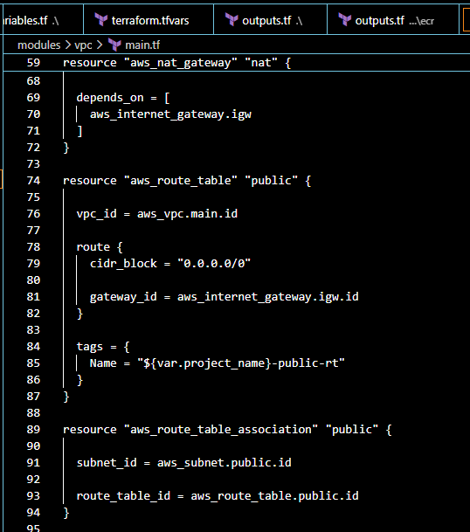
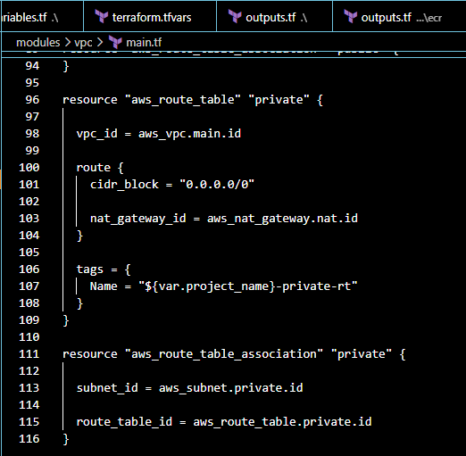
Output.tf file for vpc
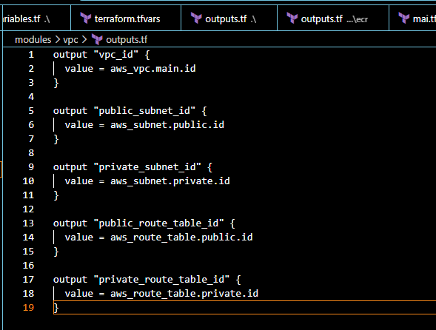
variables.tf for vpc
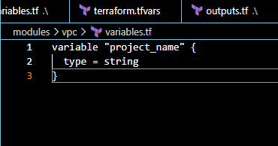
Executed all these comands terrform init, terrform fmt, terraform validate, terraform plan, terrafprm apply
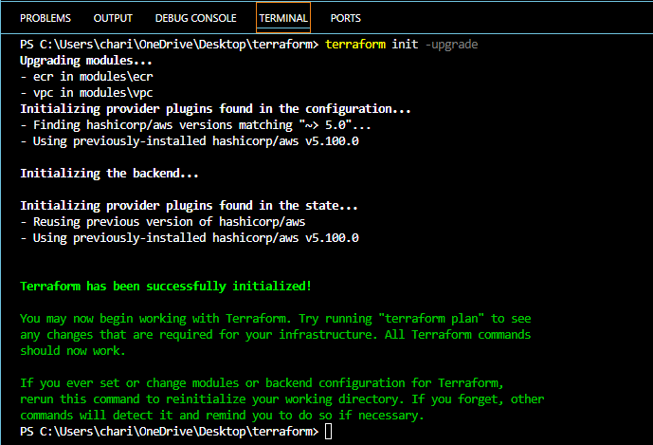
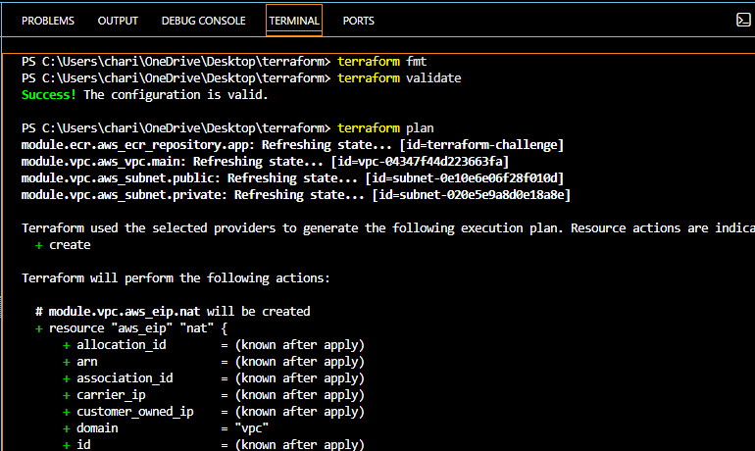
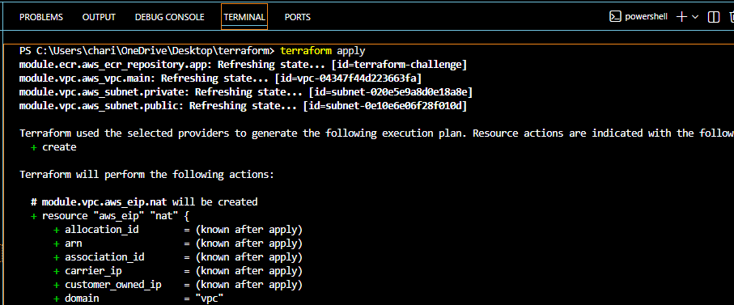
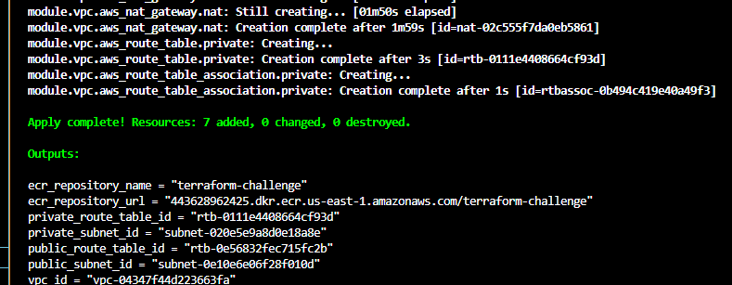
Verified in AWS account vpc, subnets and routing tables attached IGW and NAT
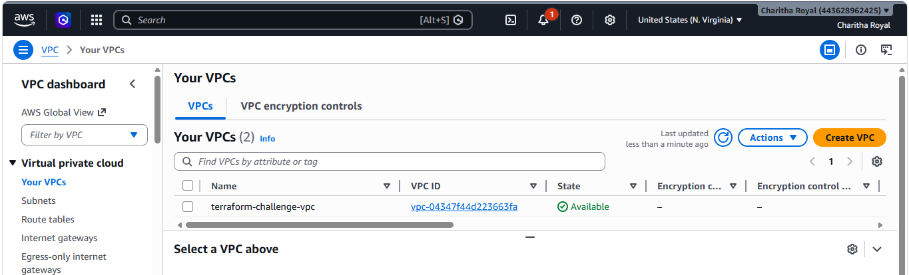
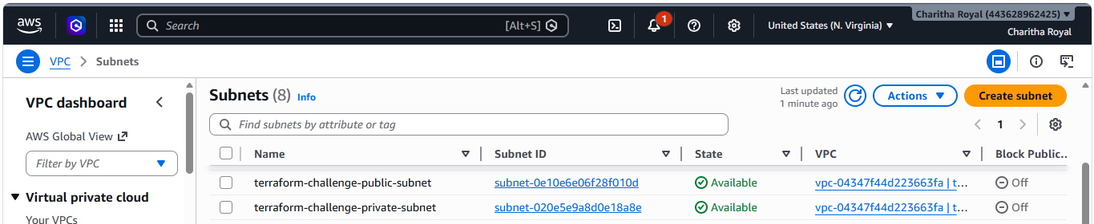
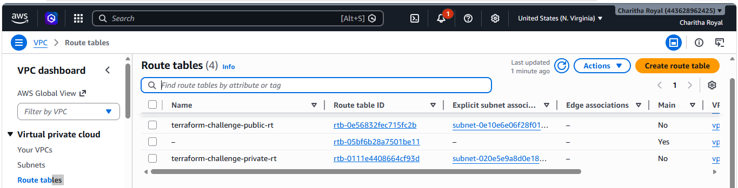
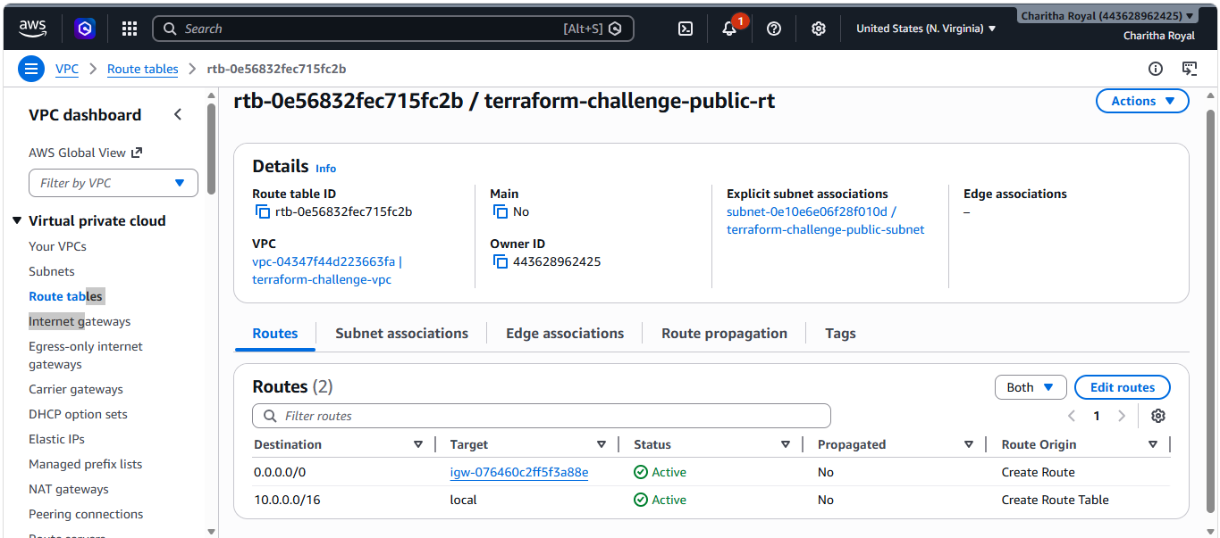
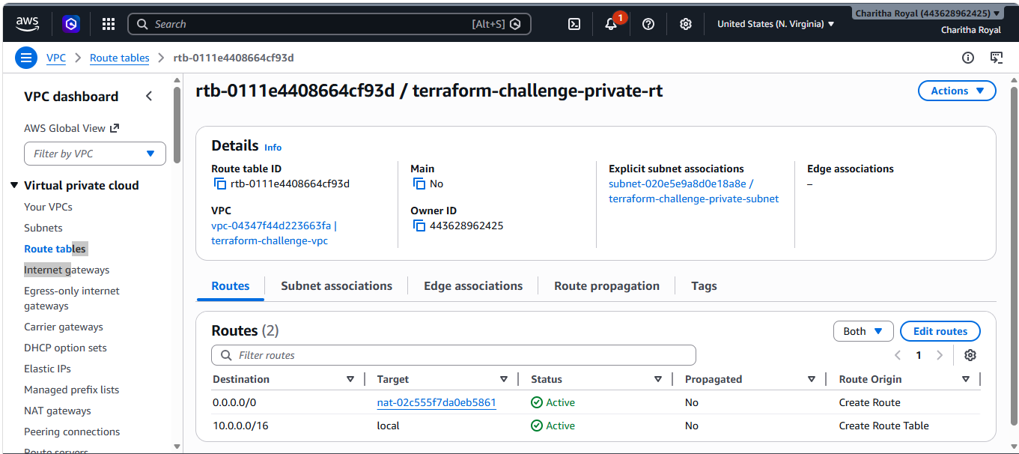

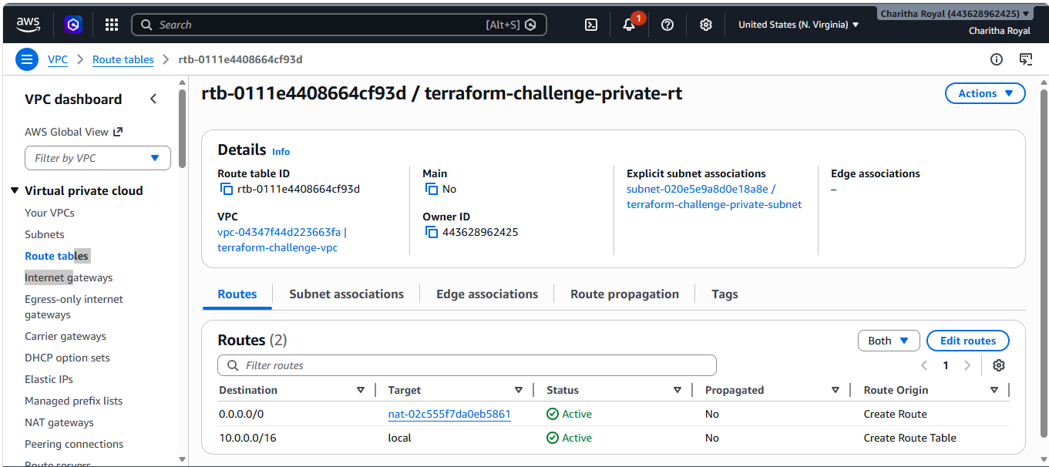
EC2(Elastic cloud container)
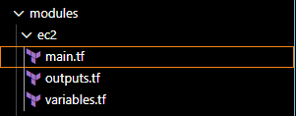
main.tf
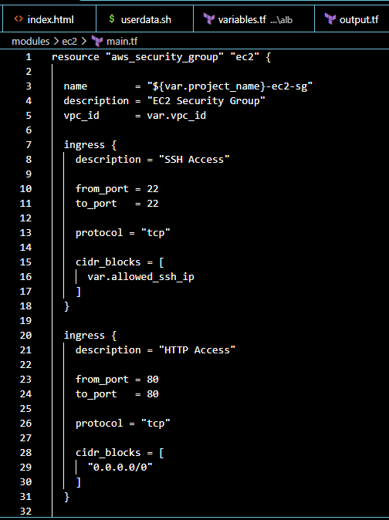
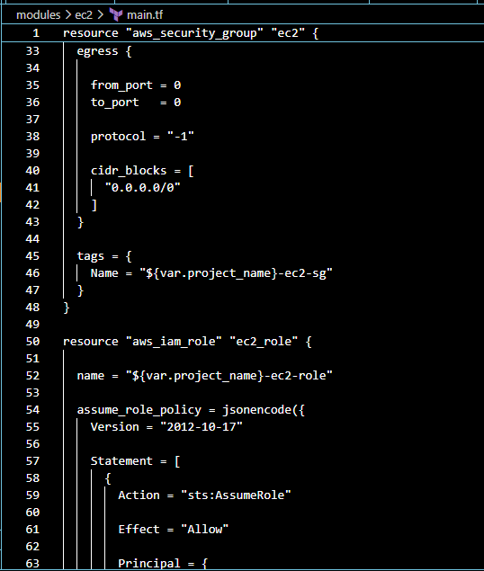
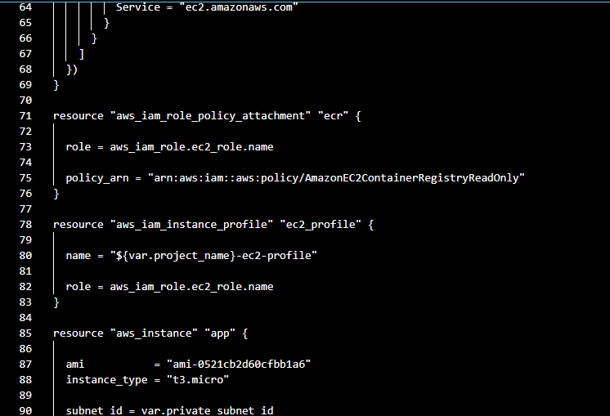
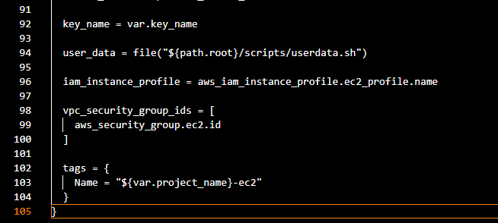
output.tf
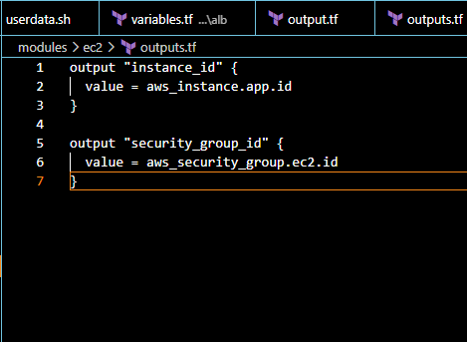
variables.tf
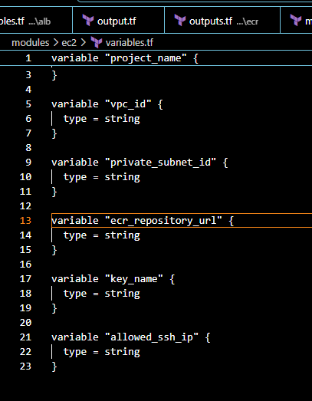
Executed all these comands terrform init, terrform fmt, terraform validate, terraform plan, terrafprm apply
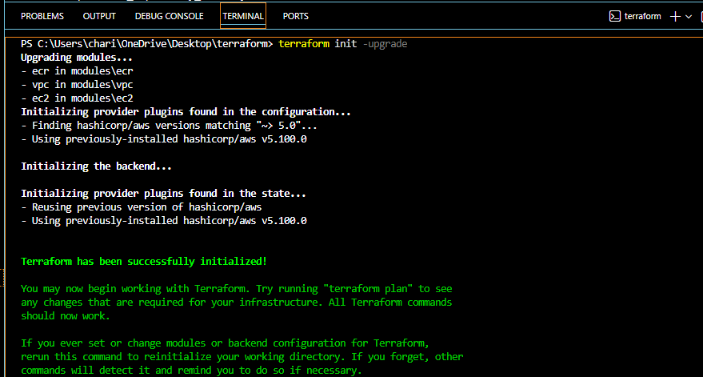
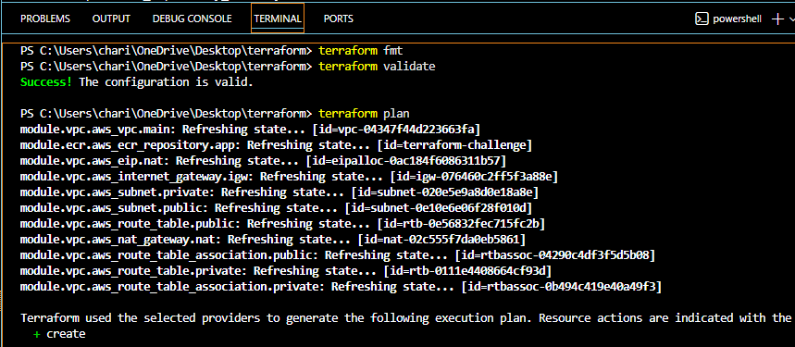
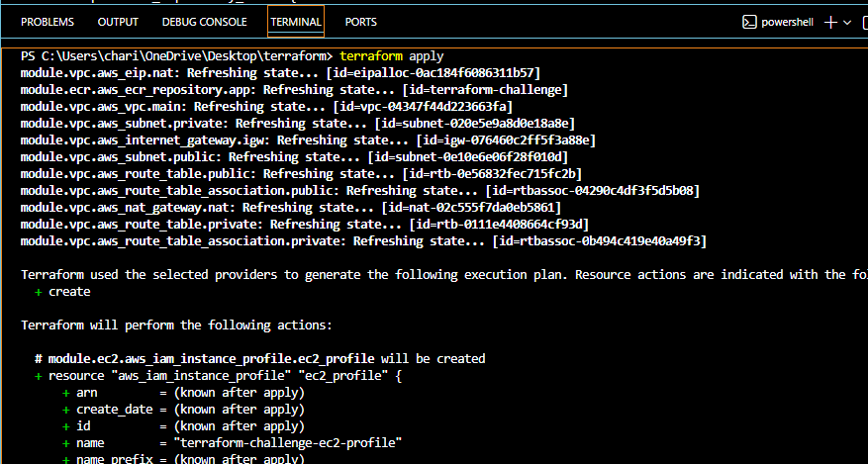
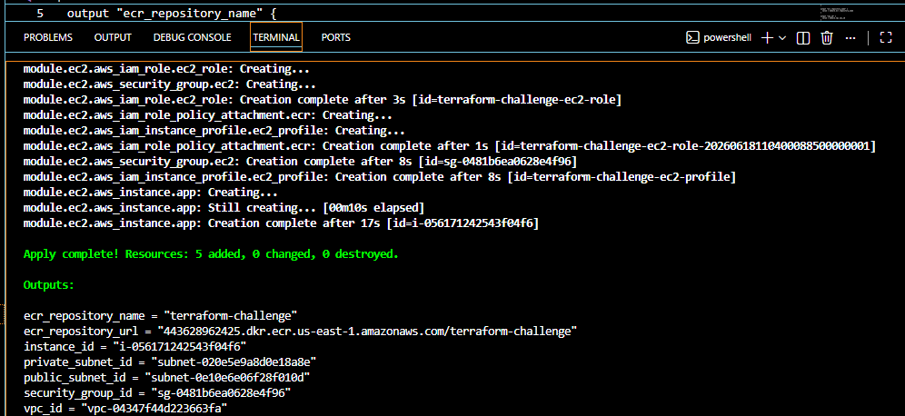
Verified in AWS account EC2 instance is created
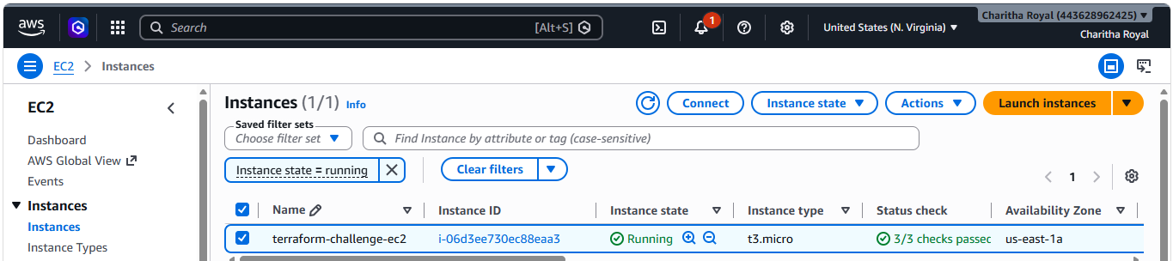
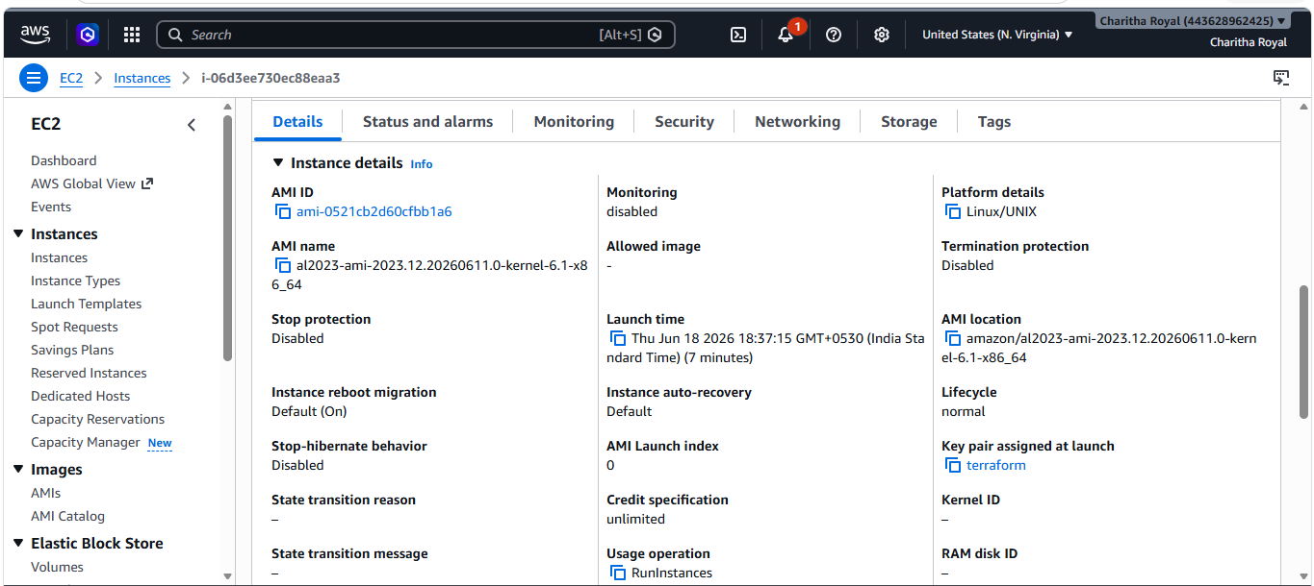
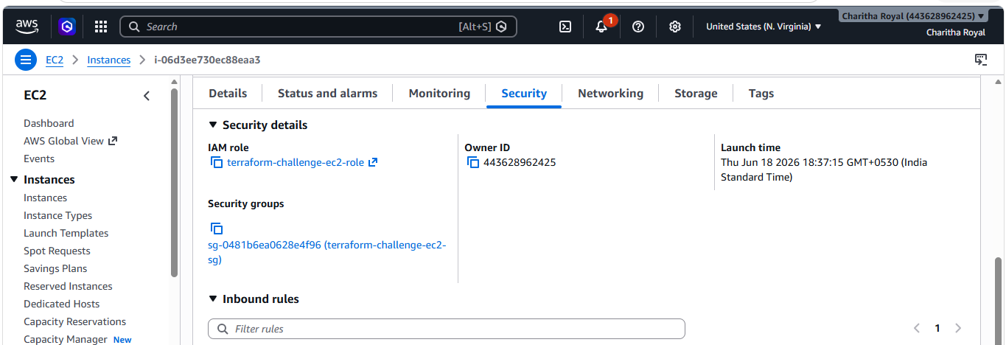
Target Group also healthy
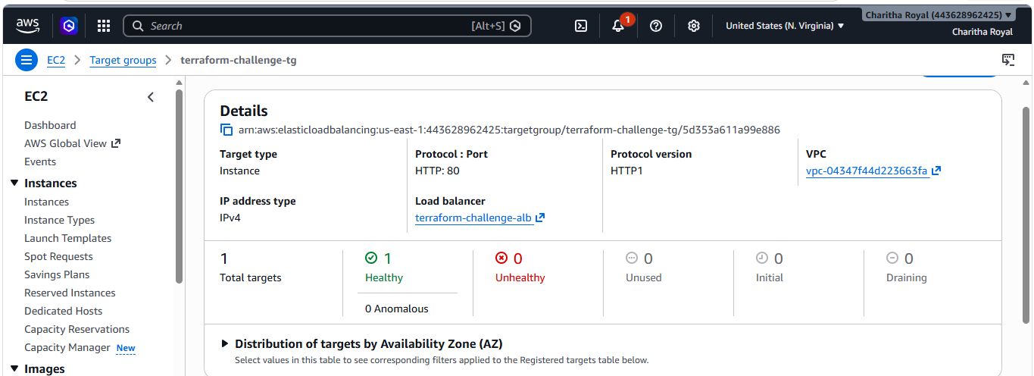
IAM Role is attached to EC2 instance
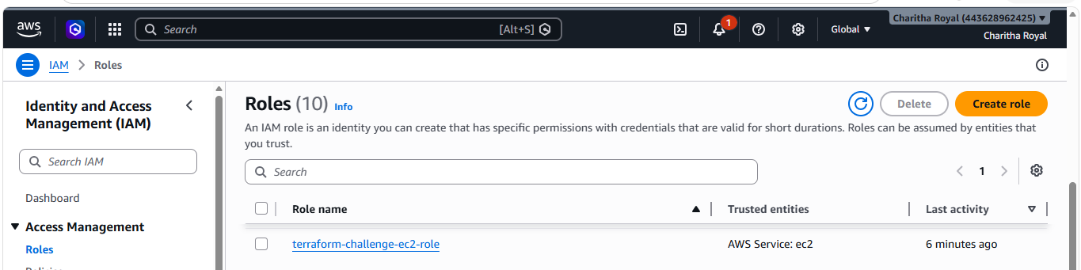
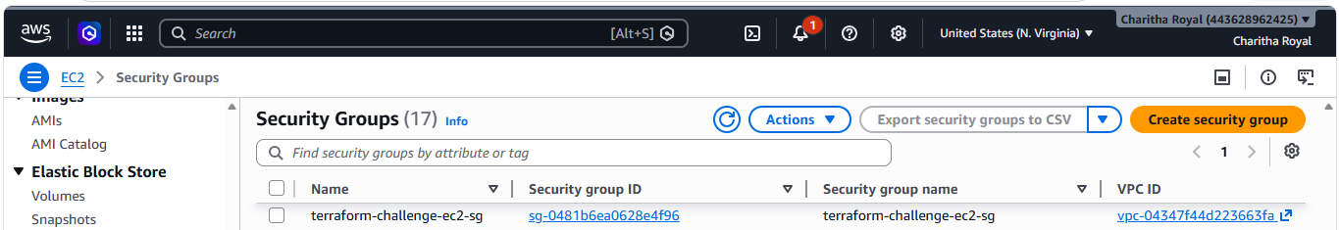
ALB (Application Load Balancer)
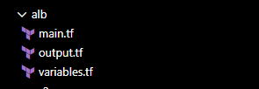
main.tf
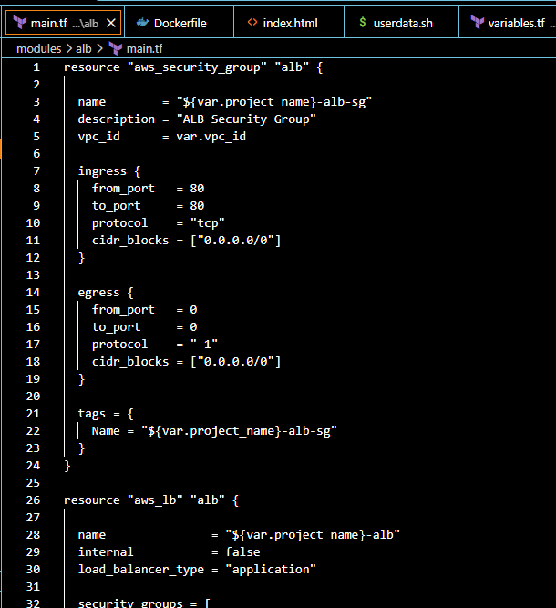
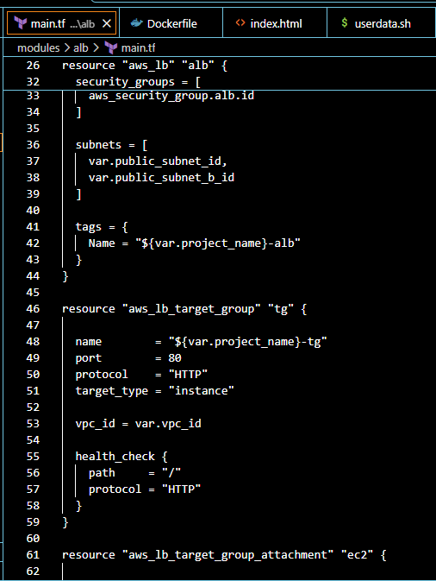
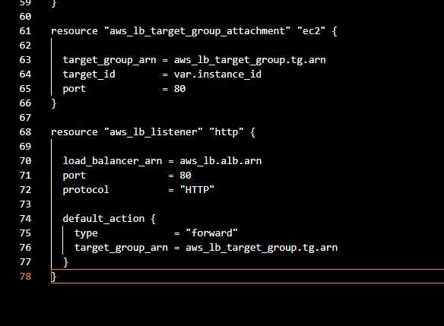
output.tf
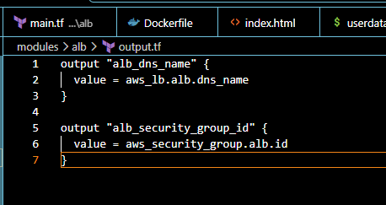
variables.tf
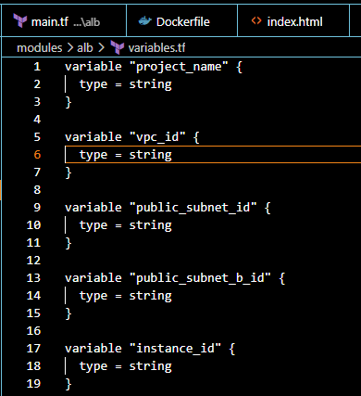
Executed all these comands terrform fmt, terraform validate, terraform plan, terrafprm apply
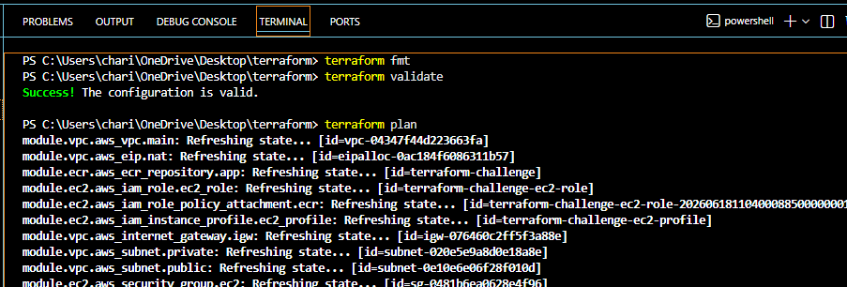
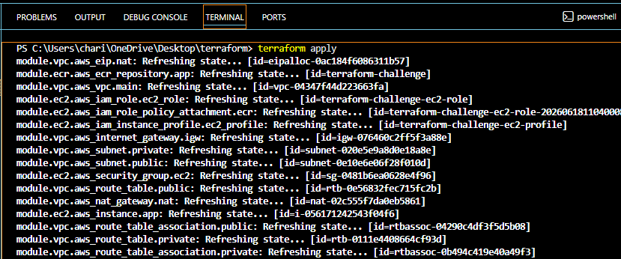
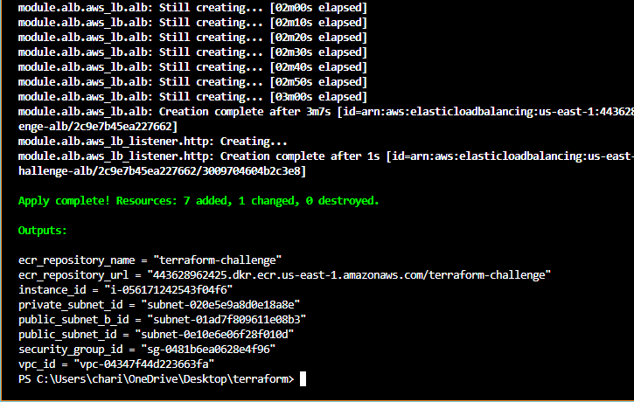
Verified in AWS account load balancer is created
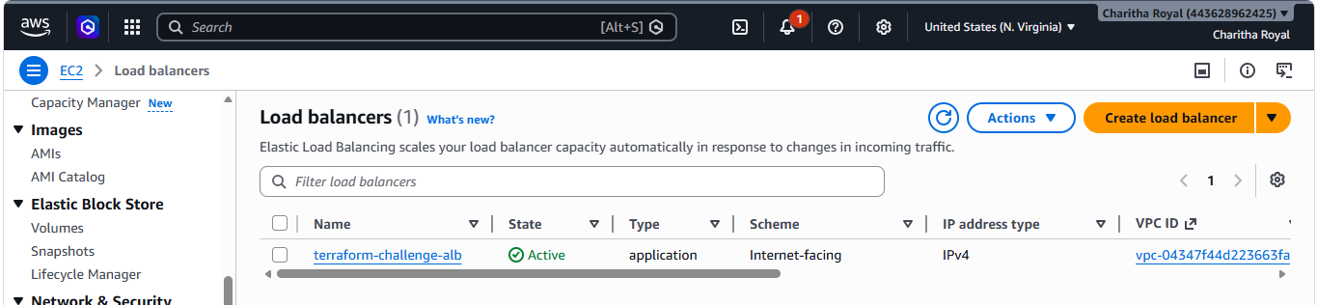
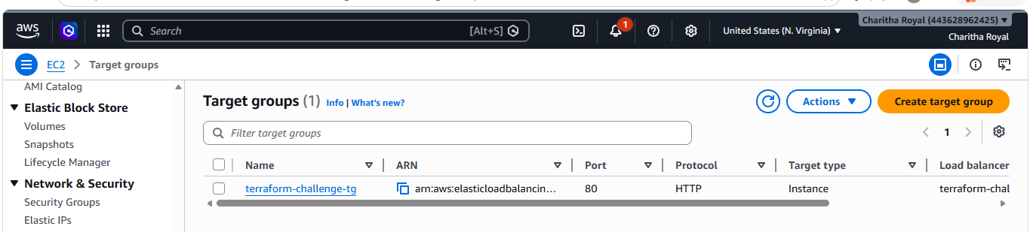
Created Scripts
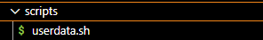
userdata.sh
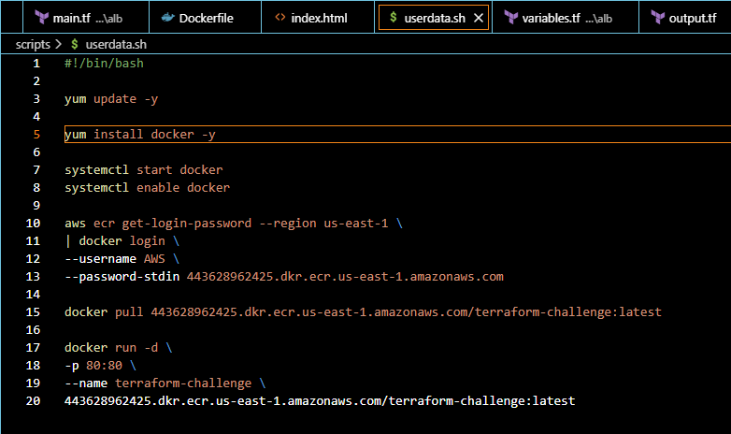
Created app
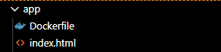
Dockerfile
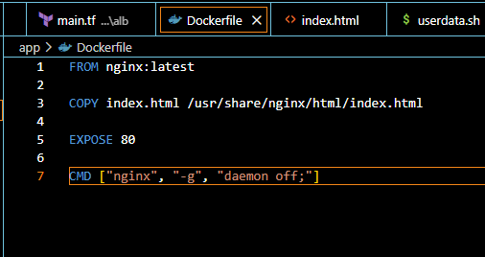
index.html
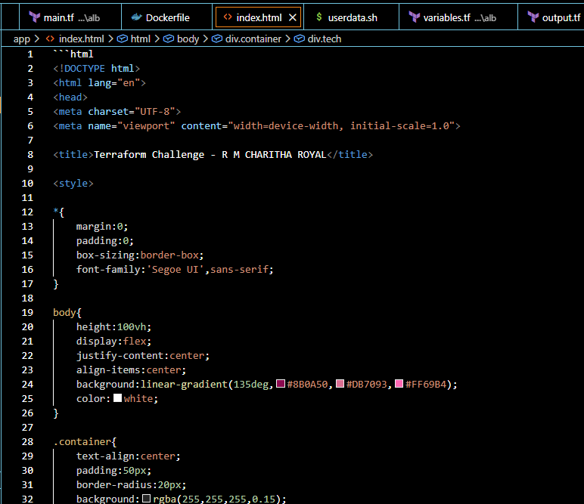

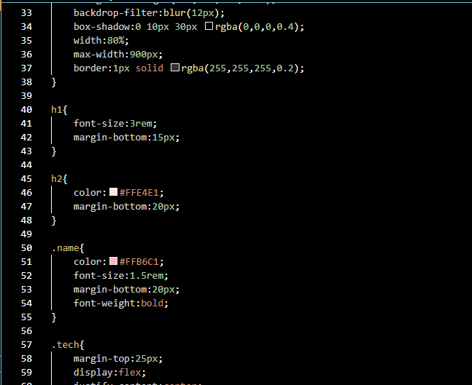
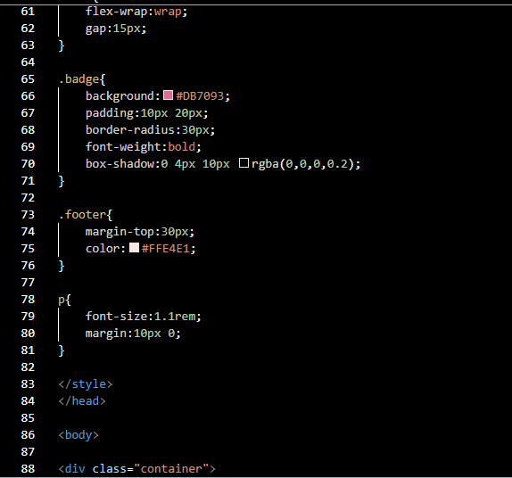
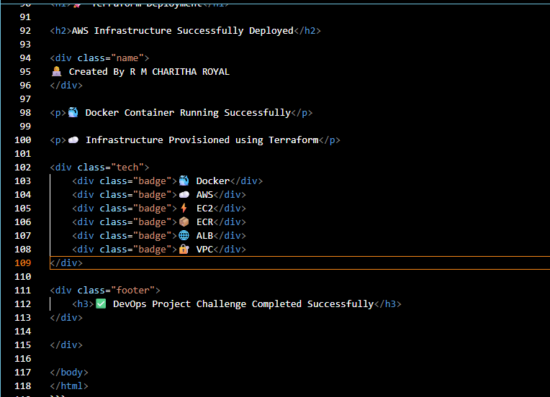
Installed docker desktop and verified docker version PowerShell
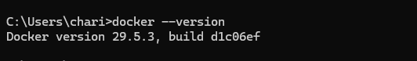
Build docker image
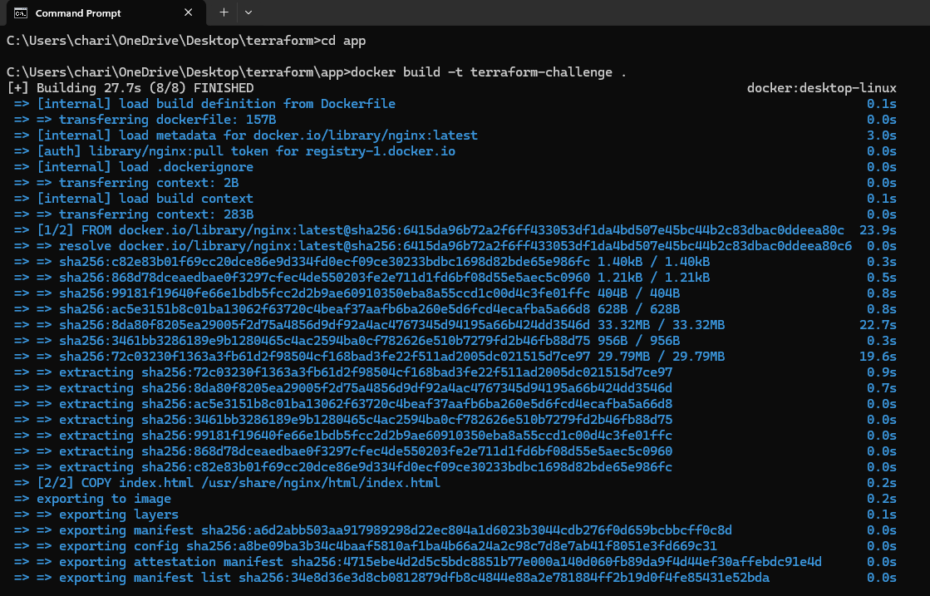
Verified docker image and pushed and tagged docker image
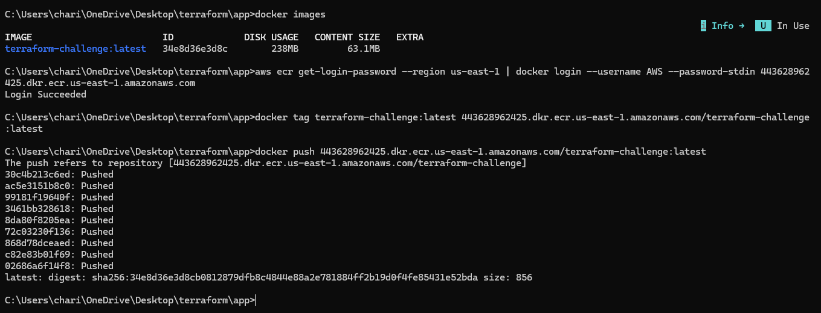
Image pushed to ECR Registry
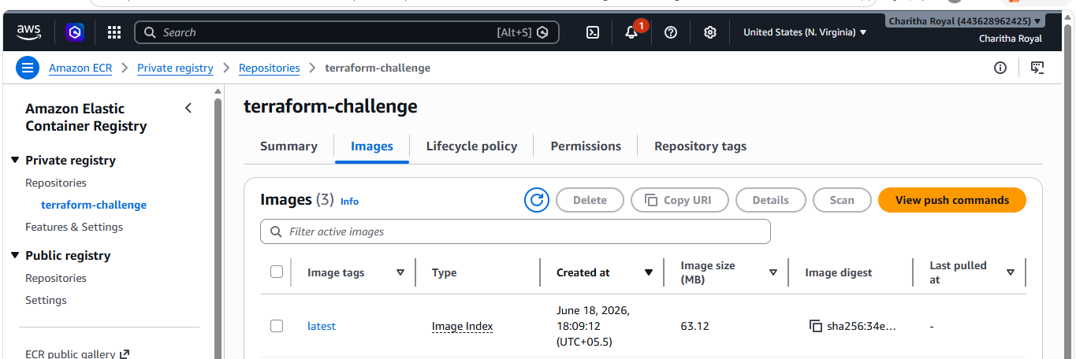
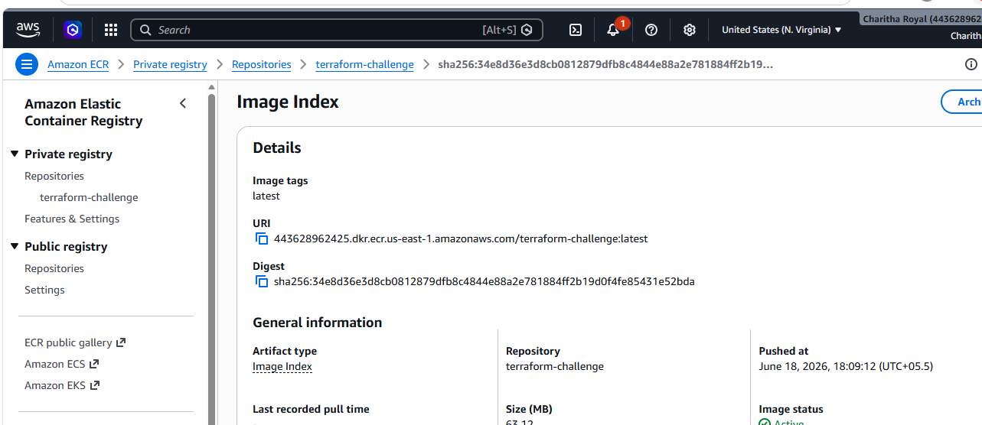
Verified index.html file with Load balancer DNS it executed successfully
